Assignment 3 Report

In the assignment the first requirement was to make a vector of size n and store in it values taken from the user. Then in the second requirement I made a function that goes through every element of the vector after taking two values from the user, *firstValue* and *secondValue*, every time the *firstValue* is found in the vector the code automatically adds the *secondValue* after it.

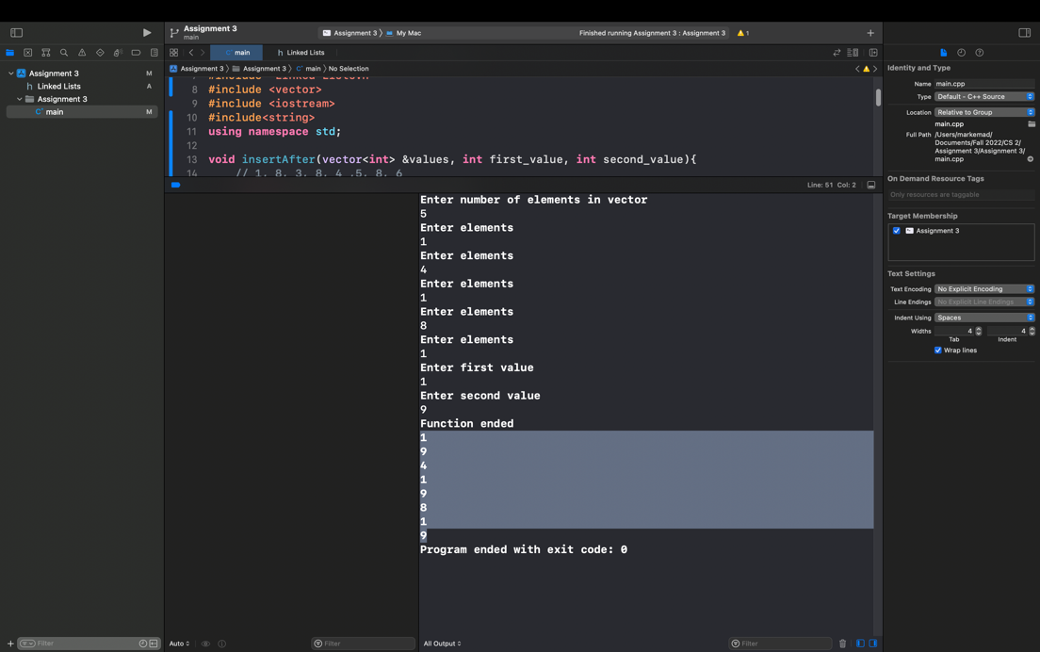

Then I made a class, Linked List, that has a structure, Node, that has pointer called next and the value inside the node and the number of occurrences. It has member functions that add nodes at the beginning, middle and end; deletes nodes and print functions of the linked list. Another two function one that makes the linked list and fill it with the elements in the vectors and checks if the number occurs in the vector more than once it is reflected in the number of occurrences in the Node; the last functions calculates the sum of all values in the linked list, to do this the function move along all the linked list with a while loop to calculate all values.

I used as reference in my codes geeksforgeeks.org and softwaretestinghelp.com.